Brian Lopez

CPE301 – SPRING 2018

Design Assignment 2

**DO NOT REMOVE THIS PAGE DURING SUBMISSION:**

The student understands that all required components should be submitted in complete for grading of this assignment.

|  |  |  |  |
| --- | --- | --- | --- |
| **NO** | **SUBMISSION ITEM** | **COMPLETED (Y/N)** | **MARKS**  **(/MAX)** |
| 1 | COMPONENTS LIST AND CONNECTION BLOCK DIAGRAM w/ PINS |  |  |
| 2. | INITIAL CODE OF TASK 1/A |  |  |
| 3. | INCREMENTAL / DIFFERENTIAL CODE OF TASK 2/B |  |  |
| 3. | INCREMENTAL / DIFFERENTIAL CODE OF TASK 3/C |  |  |
| 3. | INCREMENTAL / DIFFERENTIAL CODE OF TASK 4/D |  |  |
| 3. | INCREMENTAL / DIFFERENTIAL CODE OF TASK 5/E |  |  |
| 4. | SCHEMATICS |  |  |
| 5. | SCREENSHOTS OF EACH TASK OUTPUT |  |  |
| 5. | SCREENSHOT OF EACH DEMO |  |  |
| 6. | VIDEO LINKS OF EACH DEMO |  |  |
| 7. | GOOGLECODE LINK OF THE DA |  |  |
|  |  |  |  |
|  |  |  |  |

1. **COMPONENTS LIST**

For Tasks 1, 3, and 4:

* Atmega328P
* Programmer for the chip
* One 5K resistor that is connected to port B.2
* One LED light

For Tasks 2, and 5:

* Same as above
* Another 5K resistor that is connected to port D.2
* One pushbutton, one side connects to the resistor and the other side to ground

1. **CODE OF TASK 1/A**

; Design Assignment 2, task 1

; Blinks an LED with a DC of 50% and a period of .5 sec

start:

SBI DDRB, 2 ; set port b.2 as an output port

LDI R17, 0x00

OUT PORTB, R17 ; turn led off first

myLp:

RCALL delay ; make a delay

LDI R17, 0x80

OUT PORTB, R17 ; turn led on

RCALL delay ; make another delay

LDI R17, 0x00

OUT PORTB, R17 ; turn led off

RJMP myLp

delay:

LDI R18, 125

delLp1:

LDI R19, 228

delLp2:

NOP

NOP

NOP

NOP

DEC R19

BRNE delLp2

DEC R18

BRNE delLp1

RET

1. **CODE OF TASK 1/B**

#include <avr/io.h>

#define *F_CPU* 100000UL

#include <util/delay.h>

/*

DA2_task1 in c

This will toggle an led on/off with a period of .5 sec.

*/

int main(void)

{

DDRB = (1<<PB7); // set pb7 as an output

while(1)

{

PORTB ^= (1<<PB7); // flip port7 on/off

*_delay_ms*(2500); // delay for .25 sec

*_delay_ms*(1);

}

}

1. **CODE OF TASK 2/A**

; Design Assignment 2, task 2 in assembly

start:

CBI DDRD, 2 ; set port d.2 as an input

SBI DDRB, 2

LDI R17, 0x04

OUT PORTB, R17 ; load 1 to port b.2

again:

SBIC PIND, 2 ; check if d.2 is clear (0). means button is pressed

RJMP ledOff ; if not pressed, just turn the led off by making it an input

SBI PORTB, 2 ; Button is pressed, turn led on by setting is as output

LDI R21, 4 ; The timer below is for ~0.25 seconds, so repeat that 4 times to get one second

timer:

LDI R20, 60

OUT TCNT0, R20 ; load value for timer to start

LDI R20, 0x00

OUT TCCR0A, R20 ; normal mode

LDI R20, (1<<CS02 | 1<<CS00) ; 1024 prescalar

OUT TCCR0B, R20

tLp:

IN R20, TIFR0 ; read timer value

SBRS R20, 0 ; if not done, keep checking

RJMP tLp

LDI R20, 0x0

OUT TCCR0B, R20 ; stop the timer

LDI R20, (1<<TOV0)

OUT TIFR0, R20 ; clear the flag

DEC R21

CPI R21, 0 ; check if this has been done 4 times, if not

BRNE timer ; repeat

CBI PORTB, 2 ; after 1 second, turn led off again by setting it as an input.

RJMP again

ledOff:

CBI PORTB, 2 ; turns the led off by setting it as an input.

RJMP again

1. **CODE OF TASK 2/B**

// Design Assignment 2, task 2 in c

#include <avr/io.h>

int main(void)

{

DDRB |= (1<<2); // set pinb.2 as an output

DDRD |= (0<<2); // set pind.2 as an input

PORTB = 0x00; // initially have the led off

while(1)

{

if (!(PIND & 0x04)) // wait until the switch is pressed (pind.2 will be 0 when pressed)

{

PORTB ^= (1<<2); // turn on the led

for(int i = 0; i < 4; i++) // the timer goes on for .25 seconds, so do that 4 times to get one second

{

TCNT0 = 61; // load start value

TCCR0A = 0x00; // normal mode

TCCR0B = 0x05; // prescalar of 1024

while((TIFR0 & 0x01) == 0)

{

// wait until overflow occurs

}

TCCR0B = 0; // turn off the timer

TIFR0 |= 1<<TOV0; // reset the flag

}

PORTB ^= (1<<2); // once the for loop is done, turn the led off

}

}

}

1. **CODE FOR TASK 3/A**

start:

SBI DDRB, 7

LDI R16, 0x80

LDI R17, 0

OUT PORTB, R17

begin:

LDI R20, 61

OUT TCNT0, R20 ; load timer 0

LDI R20, 0x00

OUT TCCR0A, R20 ; normal mode for timer 0

LDI R20, (1<<CS02 | 1<<CS00) ; prescalar of 1024

OUT TCCR0B, R20

loop:

IN R20, TIFR0 ; check if overflow occurs

SBRS R20, 0

RJMP loop

LDI R20, 0x0

OUT TCCR0B, R20 ; stop the timer

LDI R20, (1<<TOV0)

OUT TIFR0, R20 ; clear the flag

EOR R17, R16

OUT PORTB, R17 ; flip led on/off

RJMP begin

1. **CODE FOR TASK 3/B**

/*

Design Assignment 2, Task 3 in C

*/

#include <avr/io.h>

int main(void)

{

DDRB |= (1<<2);

PORTB = 0;

while(1)

{

TCNT0 = 61;

TCCR0A = 0x00; // normal mode

TCCR0B = 0x05; // 1024 prescalar

while((TIFR0 & 0x01) == 0)

{

// wait until overflow occurs

}

TCCR0B = 0; // stop the clock

TIFR0 |= 1<<TOV0; // clear the flag

PORTB ^= (1<<2); // switch the led on/off

}

}

1. **CODE FOR TASK 4/A**

; Design assignment 2, task 4 in assembly

.org 0x00

RJMP start

.org 0x20

RJMP T0_overflow

start:

SBI DDRB, 2 ; set pin 2 of port b as an output

LDI R17, 0

LDI R16, 0x04

OUT PORTB, R17

begin:

LDI R19, 61 ; for timer that takes 25ms

OUT TCNT0, R19

LDI R19, 0x00 ; load normal mode into the timer

OUT TCCR0A, R19

LDI R20, (1<<CS02 | 1<<CS00) ; prescalar of 1024

OUT TCCR0B, R20

LDI R20, 0x01

STS TIMSK0, R20 ; enable the timer interupt

SEI ; enable global interupts

again:

RJMP again

T0_overflow:

LDI R20, (1<<TOV0) ; reset the interupt

OUT TIFR0, R20

EOR R17, R16

OUT PORTB, R17 ; invert the value to the led

LDI R20, 61 ; restart the timer

OUT TCNT0, R20

RETI

1. **CODE FOR TASK 4/B**

/*

Design Assignment 2, Task 4 in C

*/

#include <avr/io.h>

#include <avr/interrupt.h>

int main(void)

{

DDRB |= (1<<2); // set portb.2 as an output

PORTB = 0x00; // turn led off at beginning

TCNT0 = 61; // load timer value

TCCR0A = 0x00; // normal mode

TCCR0B = 0x05; // 1024 prescalar

TIMSK0 = (1<<TOIE0); // set overflow interrupt

sei(); // turn on global interrupts

while(1)

{

// do nothing now :)

}

}

ISR (TIMER0_OVF_vect)

{

TCNT0 = 61; // reload timer value

PORTB ^= (1<<2); // switch led on/off

TIFR0 |= (1<<TOV0); // clear the flag

}

1. **CODE FOR TASK 5/A**

.ORG 0x00

JMP main

.ORG 0x02

JMP int0Chng

.ORG 0x16

JMP time1CTC

main:

LDI R16, HIGH(RAMEND) ; initialize stack

OUT SPH, R16

LDI R16, LOW(RAMEND)

OUT SPL, R16

SBI DDRB, 2 ; set portb.2 as an output

CBI PORTB, 2 ; turn led off initially

LDI R20, HIGH(3125) ; set ctc compare value (~1 second)

STS OCR1AH, R20

LDI R20, LOW(3125)

STS OCR1AL, R20

LDI R20, 1<<OCIE1A

STS TIMSK1, R20 ; enable timer 1 interrupt

CBI DDRD, 2 ; set portd.2 as an input

LDI R20, 0x00

STS EICRA, R20

LDI R20, 1<<INT0

OUT EIMSK, R20 ; enable int0 interrupt

SEI ; enable global interrupts

lp:

RJMP lp ; be here forever!!

int0Chng:

SBI PORTB, 2 ; turn on the led

LDI R20, (1<<WGM12 | 1<<CS12) ; turn on timer 1 in ctc mode

STS TCCR1B, R20 ; and prescalar of 256

LDI R20, 1<<INTF0

OUT EIFR, R20 ; clear int0 flag

RETI

time1CTC:

CBI PORTB, 2 ; turn off led

LDI R20, 1<<OCF1A

STS TIFR1, R20 ; clear timer1 flag

LDI R20, 0x00

STS TCCR1B, R20 ; turn off timer

RETI

1. **CODE FOR TASK 5/B:**

#include <avr/io.h>

#include <avr/interrupt.h>

int main(void)

{

DDRB |= (1<<2); // set pin b.2 as an output

PORTD = 1<<2;

EICRA = 0x02; // falling edge

EIMSK = (1<<INT0); // turn on int0 interrupt

sei(); // enable global interrupts

while(1)

{

}

}

ISR (TIMER1_COMPA_vect)

{

PORTB ^= (1<<2); // turn off the LED

TIFR1 |= (1<<OCF1A); // clear the timer flag

TCCR1B = 0; // turn off the timer

}

ISR(INT0_vect)

{

PORTB ^= (1<<2); // turn on the LED

OCR1A = 3125; // Load the compare value

TCNT1 = 0;

TCCR1B |= (1<<WGM12); // CTC mode

TIMSK1 |= (1<<OCIE1A); // turn on timer1 interrupt

TCCR1B |= (1<<CS12); // prescalar of 256

EIFR |= (1<<INTF0); // clear int0 flag

}

1. **SCHEMATICS**

For Tasks 1, 3, and 4:

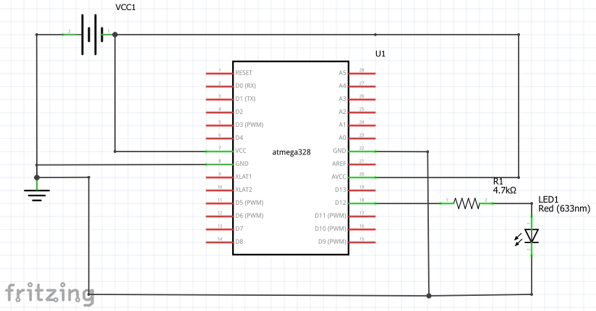

For Tasks 2 and 5:

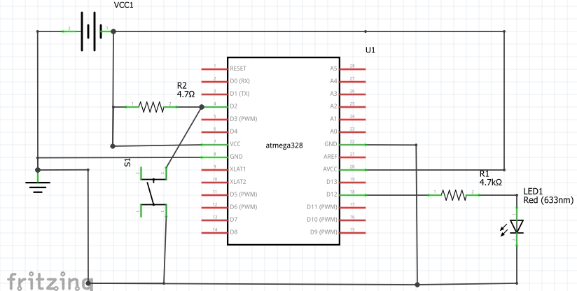

1. **SCREENSHOTS OF EACH TASK OUTPUT (ATMEL STUDIO OUTPUT)**

**For Task 1:**

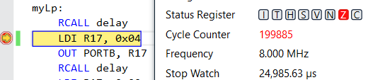

**\*change is done after the first LED change, so .25 seconds on and .25 seconds off\***

**For Task 2:**

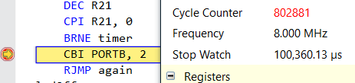

**\*Measured from button press to the LED turning off\***

**For Task 3:**

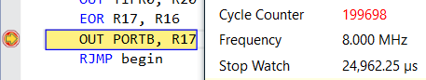

**\*Measured the same as task 1\***

**For Task 4:**

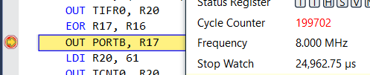

**For Task 5:**

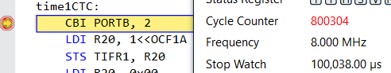

**\*Measured from button press to LED turning off\***

1. **SCREENSHOT OF EACH DEMO (BOARD SETUP)**

**For Tasks 1, 3, and 4:**

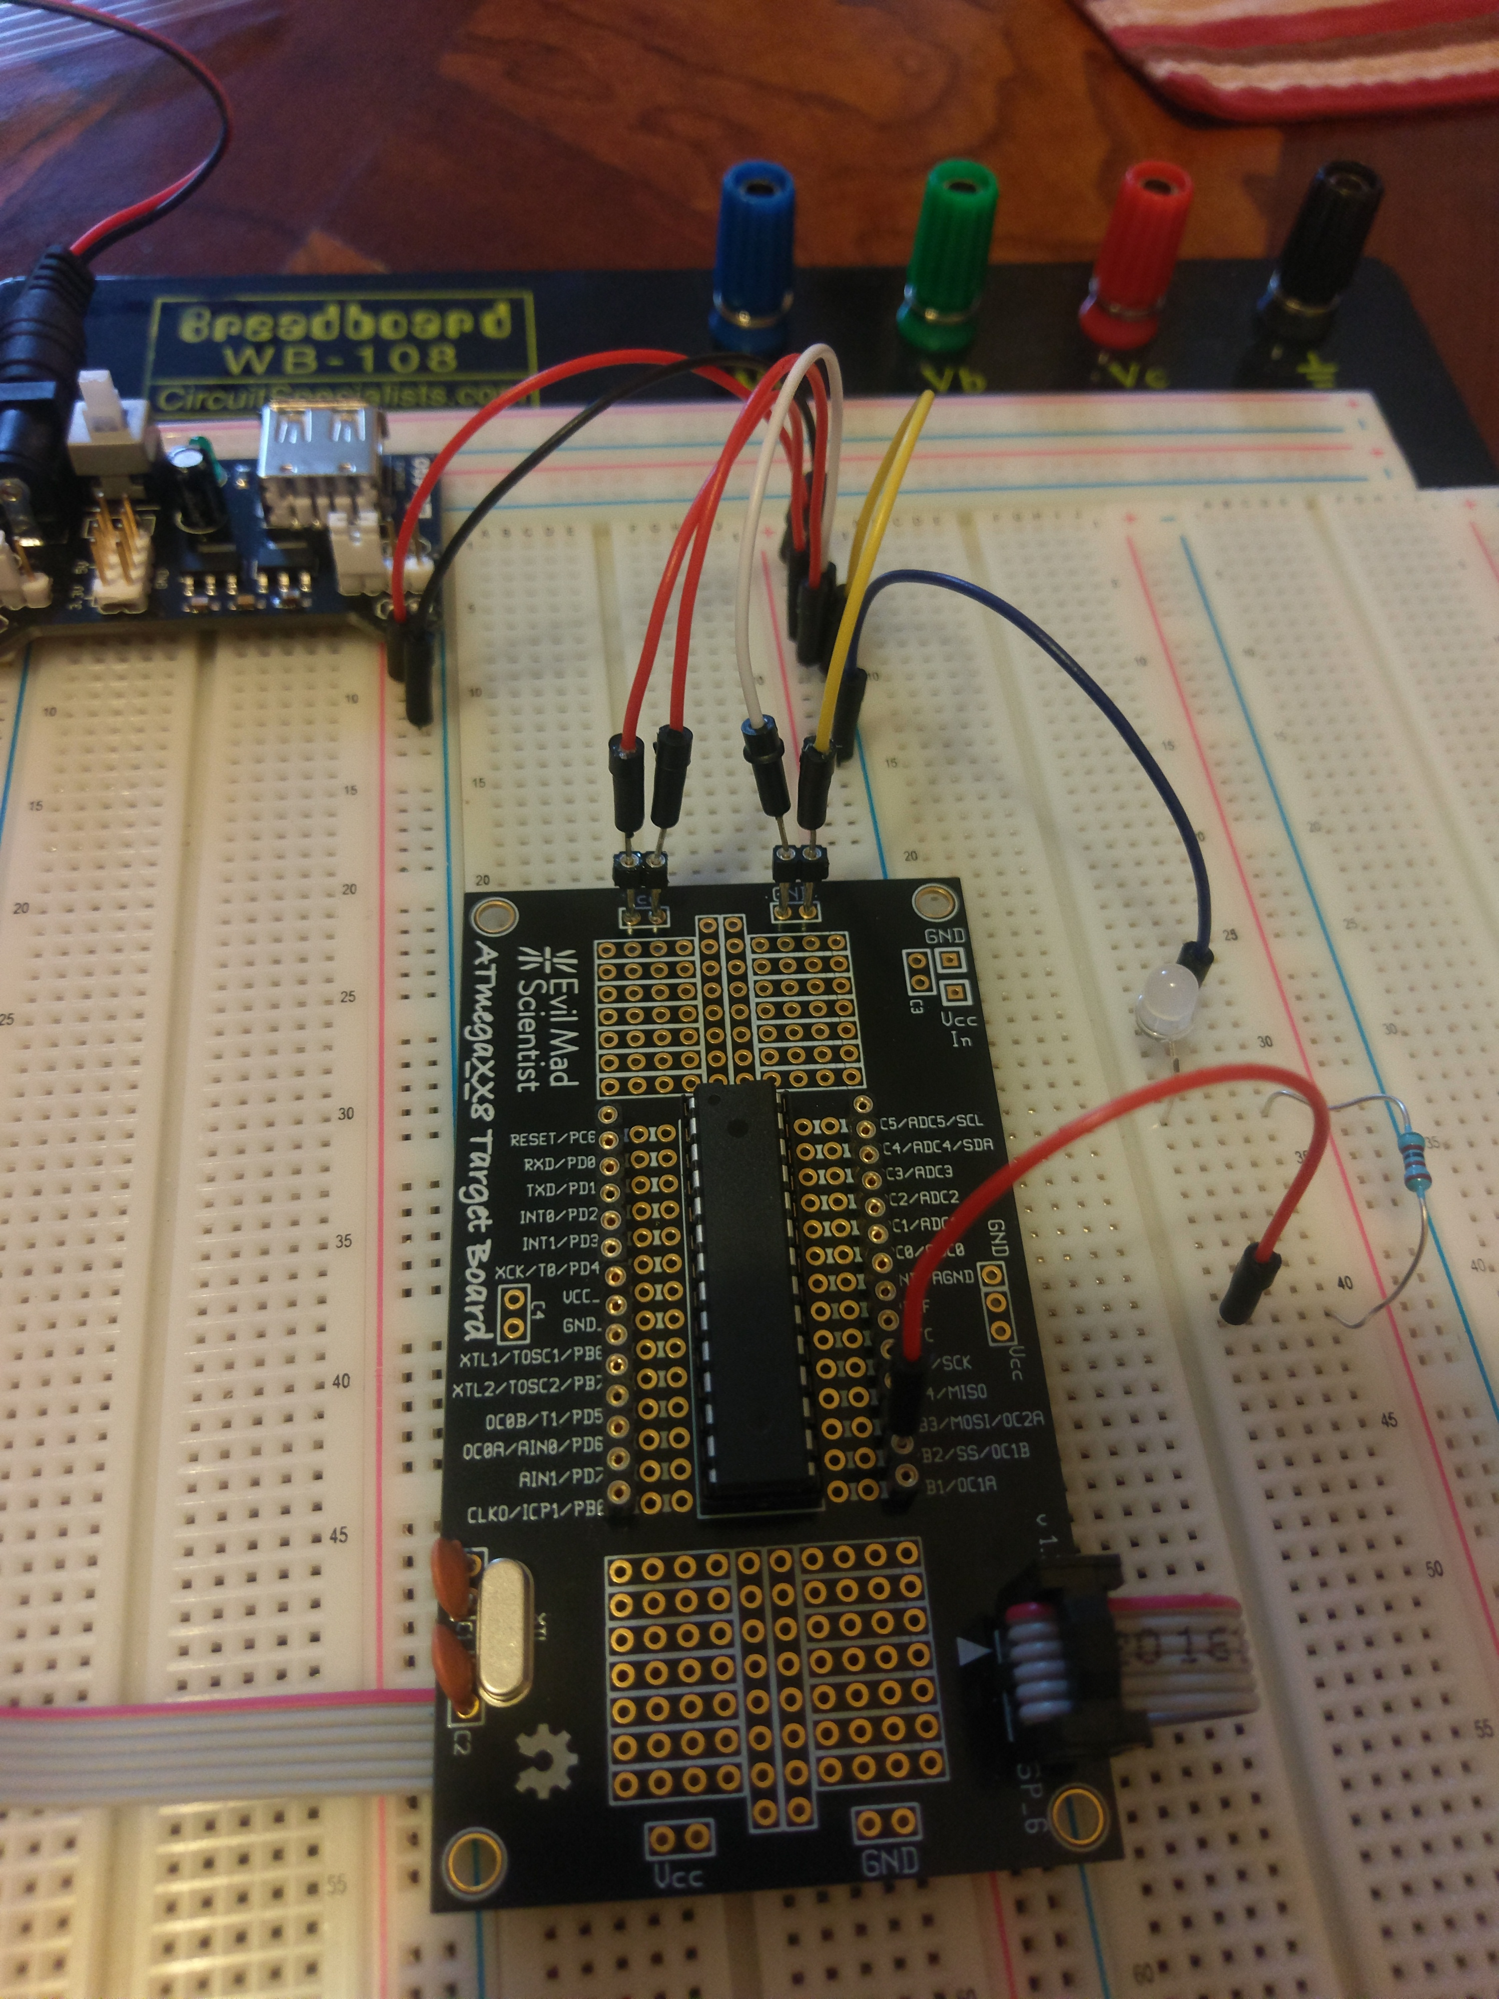

**For Tasks 2 and 5:**

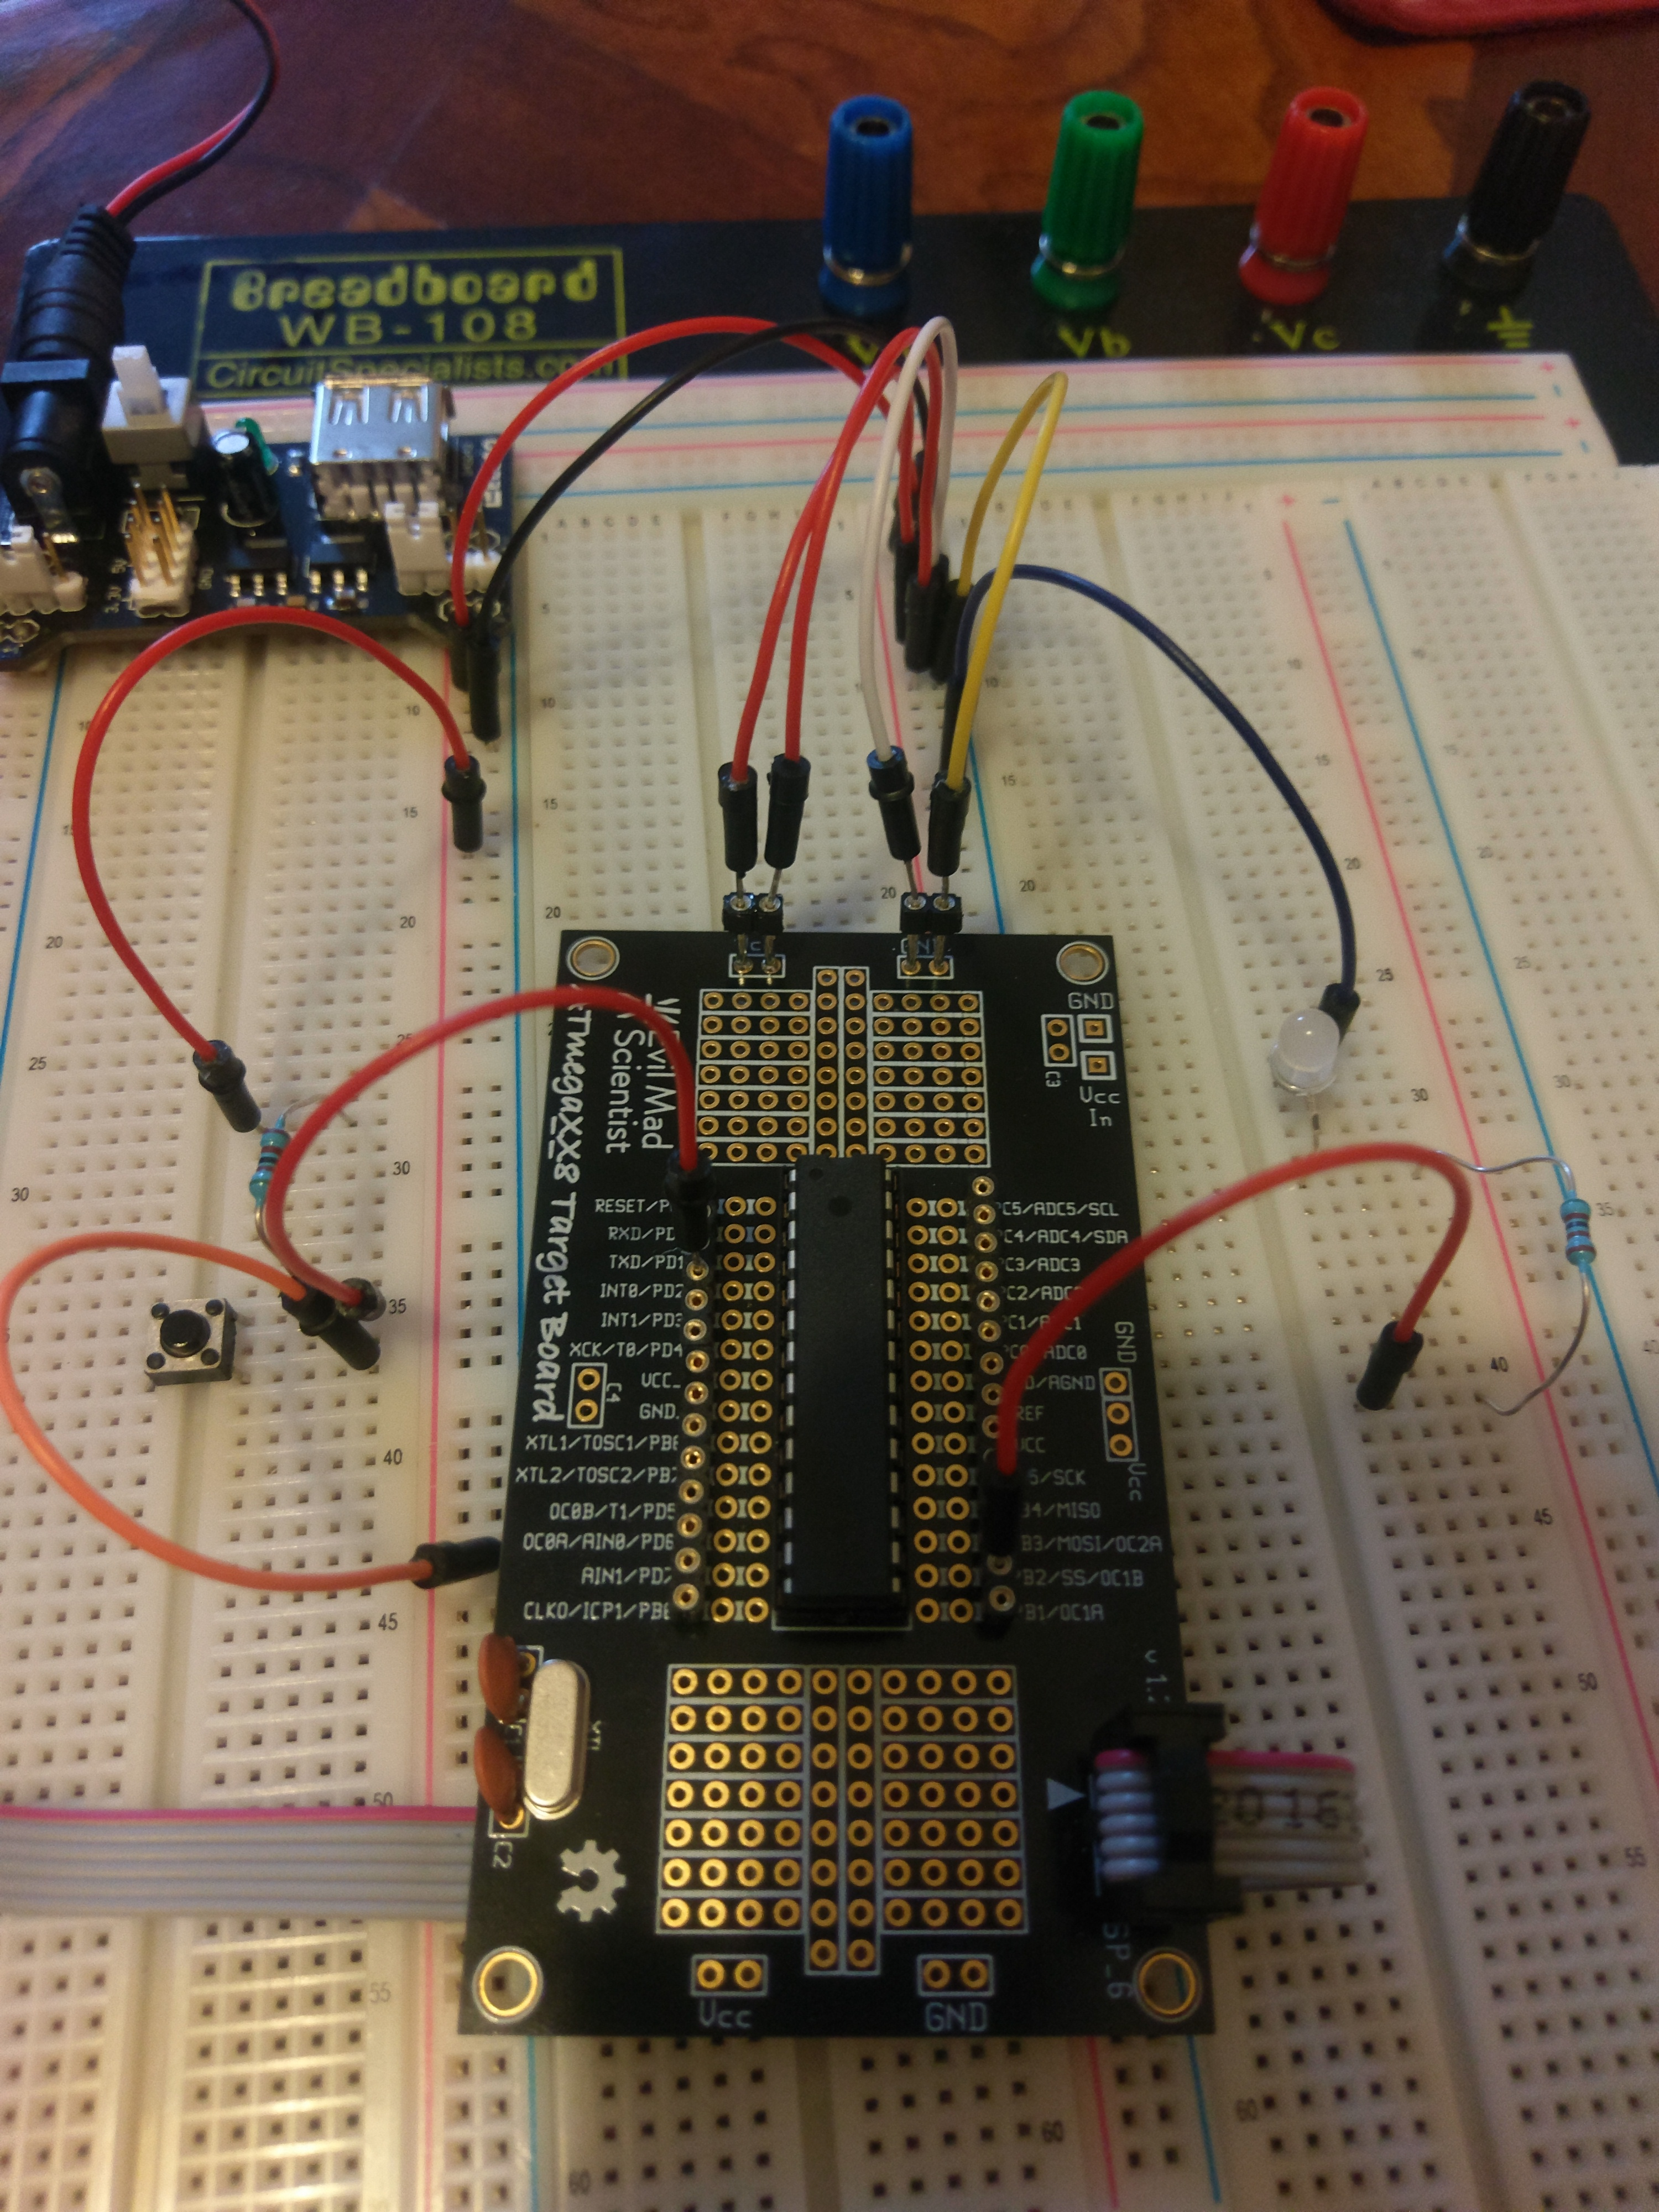

1. **VIDEO LINKS OF EACH DEMO**

Playlist that contains all of the videos:

<https://www.youtube.com/watch?v=DEEne5UPYv8&index=10&list=PL_kN1D7twBrzRnyjlp5erD3DDkbXzAMii>

**Student Academic Misconduct Policy**

<http://studentconduct.unlv.edu/misconduct/policy.html>

“This assignment submission is my own, original work”.

Brian Lopez